TOPIC: AUTOMATICALLY TOUCHLESS TOILET

FLUSHING

Most of us have seen toilets that automatically flush, usually in a public setting. They’re sometimes referred to as smart toilets or models that have a smart-flushing system.

WORKING PRINCIPLE OF THE SYSTEM

just bring your hand above the sensor or just wave your hand above the sensor, the connected servo will first rotate to the defined angle and after that, it will come back to its initial position in that rotate servo motor it pushing the button of toilet and then water start flow for flushing toilet

Application of my project

they may be popular in public restrooms and office buildings; you can easily get a touchless flush toilet in your home.

Reason of choosing my project

**Touchless** flush toilets are great at reducing contact with the **toilet** and preventing the spread of germs. Alternatively, many work on batteries, which can run out at any time.

Most people would agree that not having to touch a grimy toilet flusher is a huge advantage. Besides that, these toilets are user friendly for a variety of people, especially the elderly and those with disabilities.

They’re great for kids, too, since young ones are less likely to give their hands a good washing after using the bathroom.

these toilets are more hygienic and are great for limiting your exposure to bacteria and illness-causing germs. Their ease of use and their practicality make them a good choice for families and caregivers.

ADVANTAGES OF MY PROJECT

1. Workplace Safety

Well, this one is obvious! Restroom touchless systems like automatic faucets, soap dispensers, and hand towel dispensers are key to reducing touch points in one of the most germ-heavy areas of your workplace. The simple act of installing these systems can help to reduce the spread of viruses and bacteria within your office space.

**When employees feel comfortable using these amenities, they’ll feel more inclined to wash their hands well — every time.**Which leads to our next point!

2. Employee Efficiency

Despite all the allure of touchless systems, they won’t make employees want to hang out in the restroom any longer. In fact, seamless, easy-to-use touchless systems are known to reduce the amount of time people spend in the lavatory. That means more time hard at work! Plus, happier and healthier employees inevitably lead to boosted productivity.

3. Cost Savings

Along with the money you’ll save with less sick days and increased productivity from employees, you can also expect your water bill to be reduced! Because touchless bathroom faucets only run on-demand and towel and soap dispensers control each serving, your company will decrease its environmental footprint while saving cost on products and utilities.

We hope these unseen advantages have helped as you consider going touchless at your facility! As COVID-19 increases the importance of proper hygiene in key areas

**ALL MATERIAL WE CAN USED AND ITS FUNCTION**

* ULTRASONIC SENSOR
* ARDUINO UNO
* BREAD BOARD
* SERVO MOTORS(1)
* JUMPER WIRES
* **ULTRASONIC SENSOR**

The ultrasonic sensor emits short and high frequency signal. These signals propagate in the air at the velocity of sound. If there is an object or obstacle on its path, it will bounce back to the module. The ultrasonic sensor consists of a multi vibrator, fixed to the base. The multi vibrator is combination of a resonator and vibrator. The resonator delivers ultrasonic wave generated by the vibration. The ultrasonic sensor actually consists of two parts; the emitter which produces a 40 kHz sound wave and a detector that detects 40 kHz sound wave and sends electrical signal back to the Arduino microcontroller [3].

The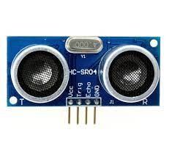HC-SR04 ultrasonic module used in this project has 4 pins, ground, VCC, trig and echo. The Ground and the VCC pins of the module needs to be connected to the ground and the 5 volts pins on the Arduino board respectively and the trig and echo pins to any digital I/O pin on the Arduino board.

* **ATRDUINO UNO**

Arduino is a small microcontroller board with a USB plug to connect to computer. It has number of connection sockets that can be wired up to external electronics, such as motors, relays, light sensors etc. They can either be powered through the USB (universal serial box) connection from the computer or from a 9V battery. They can be controlled from the computer or programmed by the computer and then disconnected and allowed to work independently

Arduino UNO- The Arduino Uno is a microcontroller board based on the AT mega 168. It has 14 digital input/output pins (of which 6 can be used as PWM (pulse width modulation) outputs), 6 analog inputs, a 16 MHz ceramic resonator, a USB connection, a power jack, an ICSP (in-circuit serial programming) header, and a reset button. It contains everything needed to support the microcontroller; simply connect it to a computer with a USB cable or power it with an AC-to-DC adapter or a battery to get started.

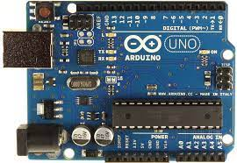

* **BREAD BOARD**

is used for building temporary circuits. It is useful to designers because it allows components to be removed and replaced easily.

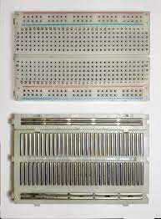

SERVO MOTOR

A **servomotor** (or **servo motor**) is a [rotary actuator](https://en.wikipedia.org/wiki/Rotary_actuator) or [linear actuator](https://en.wikipedia.org/wiki/Linear_actuator) that allows for precise control of angular or linear position, velocity, and acceleration.[[1]](https://en.wikipedia.org/wiki/Servomotor#cite_note-1) It consists of a suitable motor coupled to a sensor for position feedback. It also requires a relatively sophisticated controller, often a dedicated module designed specifically for use with servomotors.

Servomotors are not a specific class of motor, although the term *servomotor* is often used to refer to a motor suitable for use in a [closed-loop control](https://en.wikipedia.org/wiki/Closed-loop_control) system.

) Servo Motor: - Servo having very low stall torque may not work, use a servo with at least 2.5kg-cm stall torque.do not connect positive and negative wire of servo to the Arduino board, connect them directly to the power supply.

Servomotors are used in applications such as [robotics](https://en.wikipedia.org/wiki/Robotics), [CNC machinery](https://en.wikipedia.org/wiki/CNC_machine), and [automated manufacturing](https://en.wikipedia.org/wiki/Automated_manufacturing)

JUMPER WIRES

A jump wire (also known as jumper, jumper wire, DuPont wire) is an electrical wire, or group of them in a cable, with a connector or pin at each end (or sometimes without them – simply "tinned"), which is normally used to interconnect the components of a breadboard or other prototype or test circuit, internally or with other equipment or components, without soldering

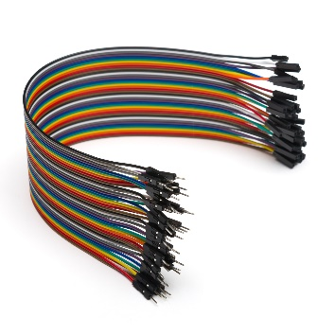

Power supply;   
about supply I have used a USB charger as a power supply. Most of the USB charger gives 5v regulated power supply.

Electrical Circuit of the system

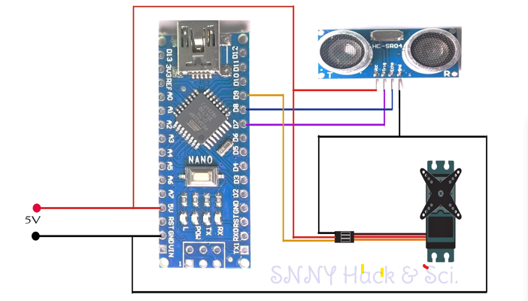

Source code of the system

#include <Servo.h>

Servo myservo;

int trig = 7;

int echo = 8;

int servo = 9;

long duration, distance;

long a[3];

void setup()

{

    myservo.attach(servo);

    pinMode(trig, OUTPUT);

    pinMode(echo, INPUT);

    myservo.write(0);   // servo position 0 degree

    delay(1000);

    myservo.detach();

}

void measure()

{

digitalWrite(trig, LOW);

delayMicroseconds(6);

digitalWrite(trig, HIGH);

delayMicroseconds(15);

digitalWrite(trig, LOW);

pinMode(echo, INPUT);

duration = pulseIn(echo, HIGH);

distance = (duration/2) / 29.1;

}

void loop()

{

  for (int i=0;i<=2;i++) {

    measure();

   a[i]=distance;

    delay(50);

  }

 distance=(a[0]+a[1]+a[2])/3;

if ( distance<70 ) // change this value to increase or decrease detection range.

{

 myservo.attach(servo);

  delay(1);

 myservo.write(90);  //servo position 90 degree

 delay(2000);

 myservo.write(0);    //servo position 0 defree

 delay(1000);

 myservo.detach();

}

}